**Part#1 INSTANCE CREATION**

* 1. Created AWS "Basic" Account  
     Log in account

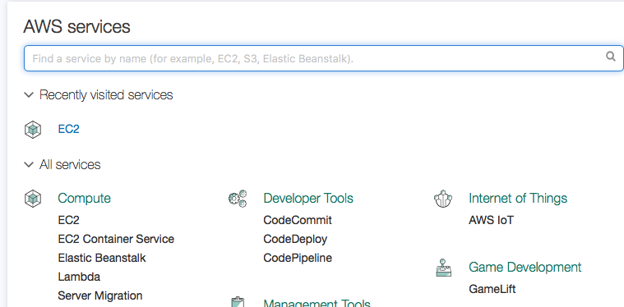

* 1. Go to AWS Marketplace,   
     Search for "Centos"

Select " CentsOS 6 [x86_64] - with Updates HVM

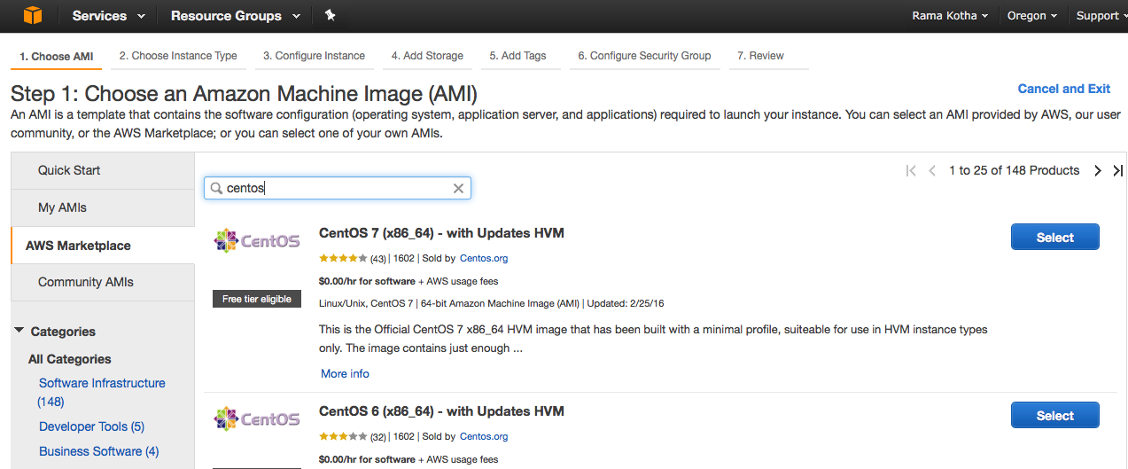

* 1. Select   
     Instance type = m4.Large  
     vCPUS = 4  
     Memory (GB) = 16

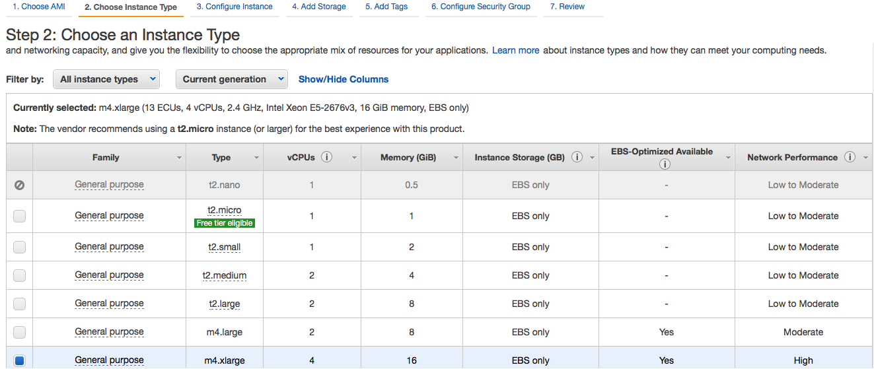

* 1. Select  
     Number of instance = 3  
     Auto-assign Public IP = Enable



* 1. Select  
     Size (GB) = 60 GB  
     Check on " Delete on Termination" , (Saves $$$)

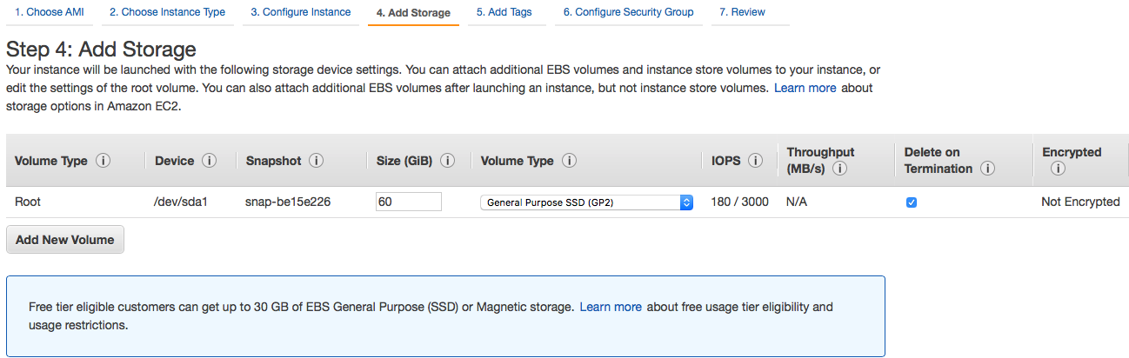

* 1. Add Tag as " CDHC"

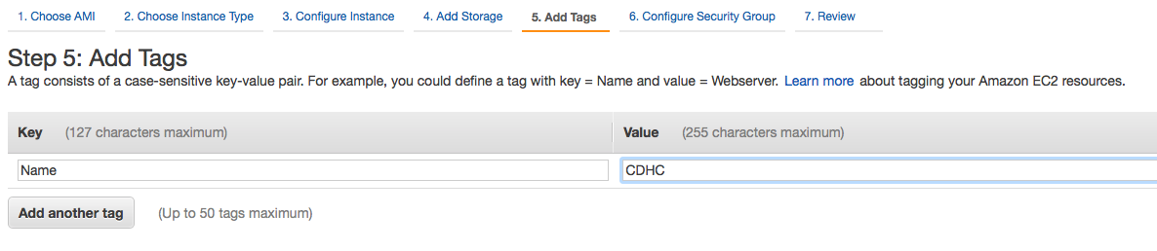

* 1. Configure Security group for Source " Anywhere"
     1. SSH
     2. All TCP
     3. All ICMP

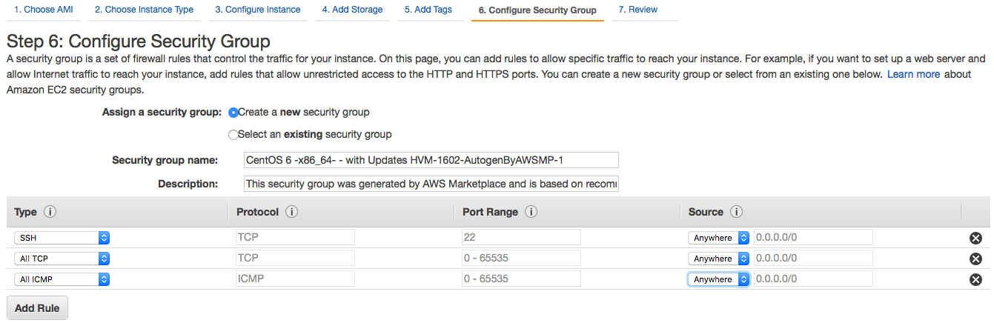

* 1. Click on "Launch"

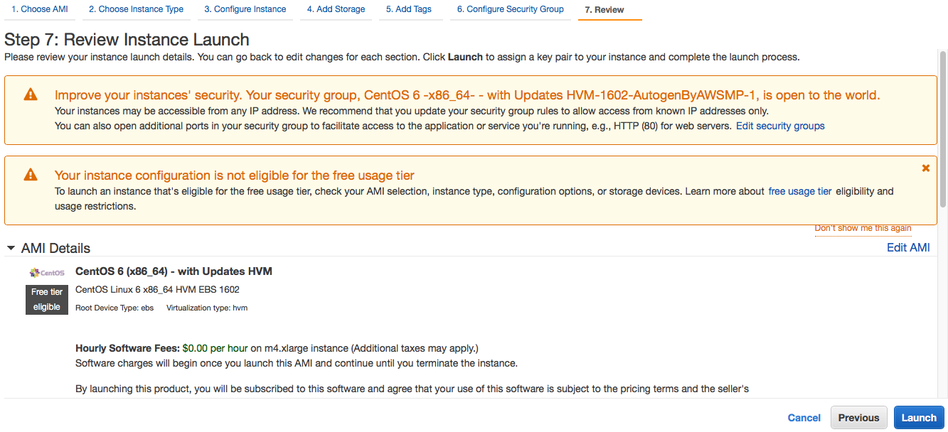

* 1. Select "Create a new key pair"

Assign Key pair name " CDHC_AWS_Hadoop", and click "Download Key Pair"  
(Note: File with "CDHC_AWS_Hadoop.pem" will be downloaded on your PC desktop or Dwnloads folder  
 If its downloaded in .txt, change its extension to .pem)  
**Launch Instance**

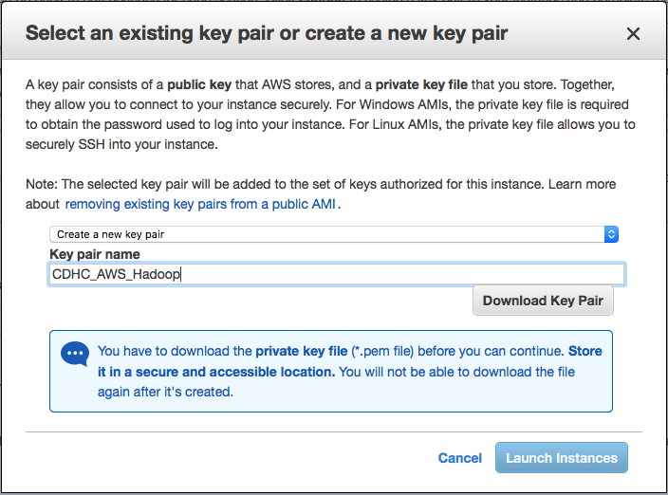

* 1. View Instances

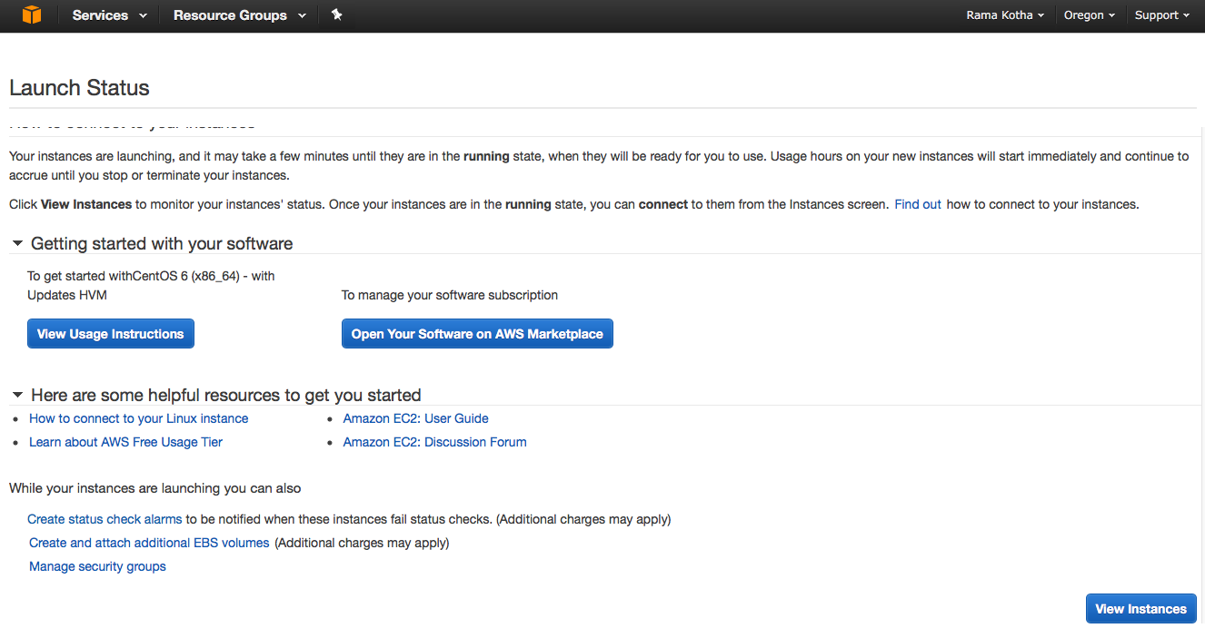

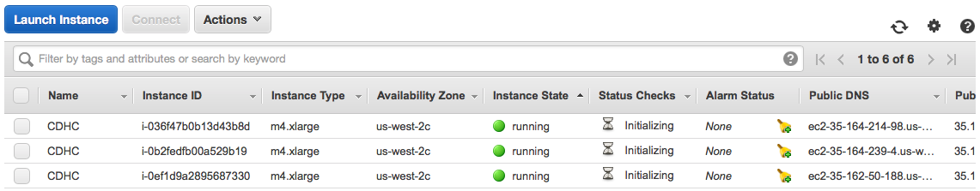

* 1. Once instances are viewed, assign "Elastic IP" to each instance

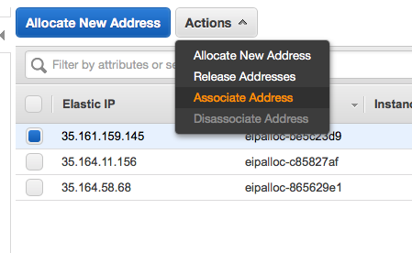

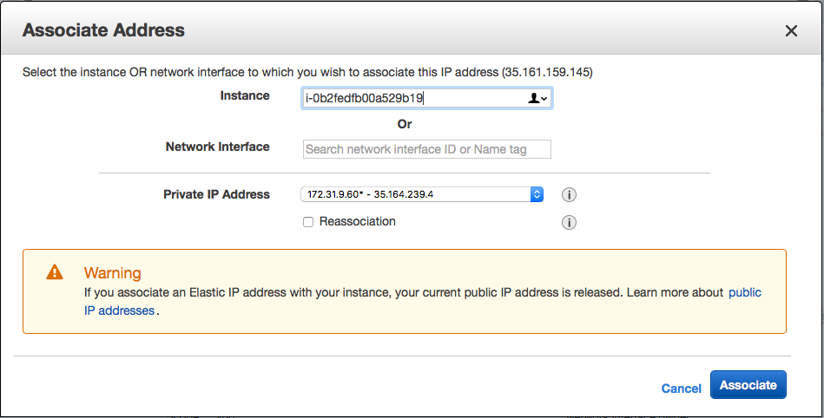

* 1. Screenshot of Instances associated with an Elastic IP

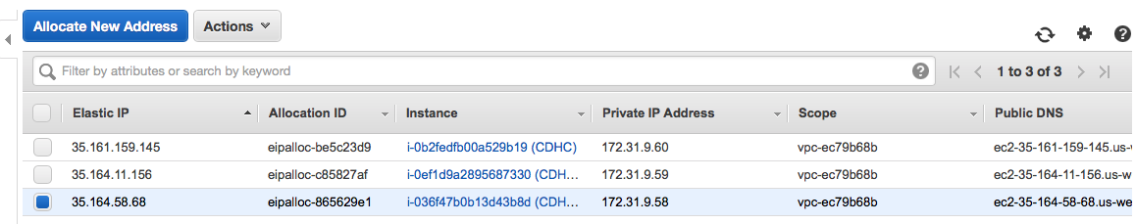

* 1. Provision Instance names with respective IP addresses  
     Example:  
     Instance name: Private IP address  
     CDHC1:172.31.9.58  
     CDHC2:172.31.9.59  
     CDHC3:172.31.9.60

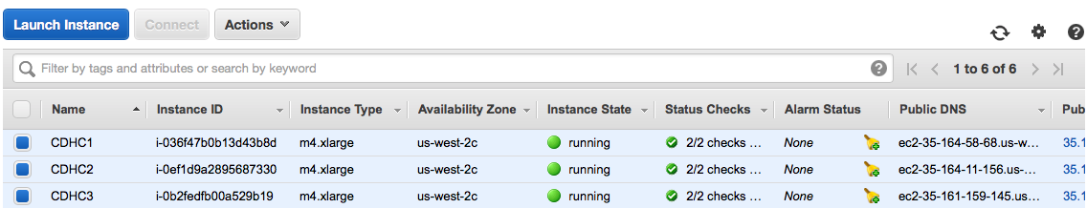

* 1. Keypair extension conversion:

As mentioned previously, Keypair, was downloaded as .txt  
Thus, it is converted to .pem in "Downloads" folder, as shown below.

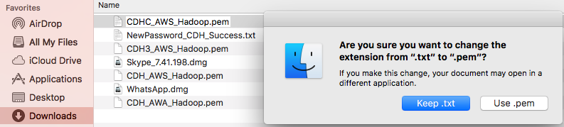

* 1. Connection to each nodes via Terminal
     1. Go to download key pair "CDHC_AWS_Hadoop" folder in your pc

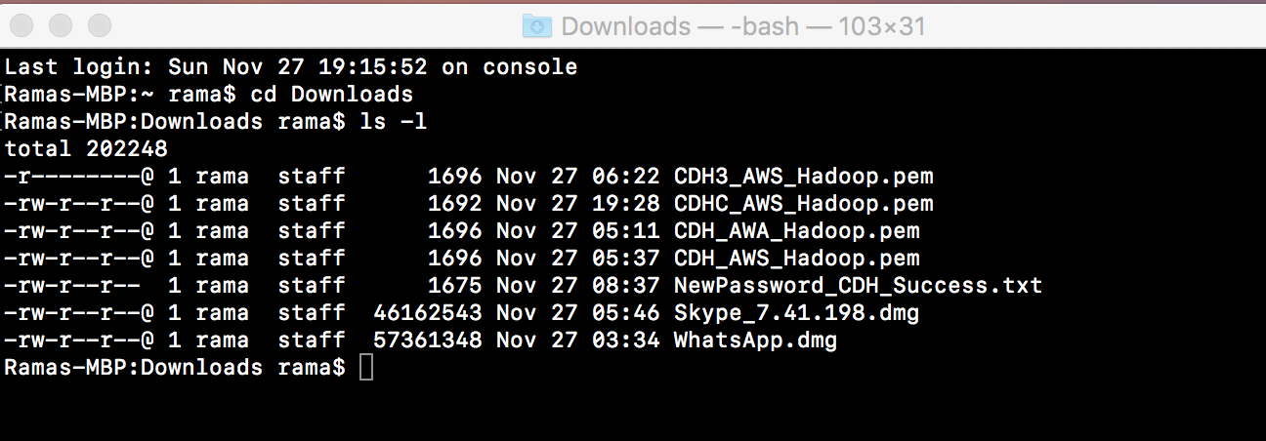

* 1. Connect instructions

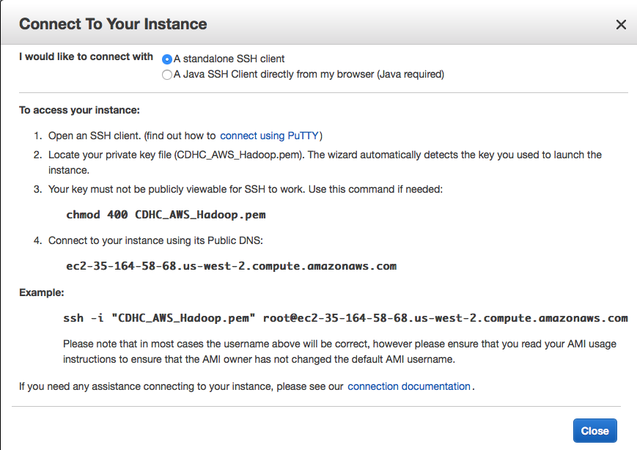

* 1. Open Terminal for "172.31.9.58", and connect to server.  
     Repeat this procedure to other IP addresses: 172.31.9.59, and 172.31.9.60

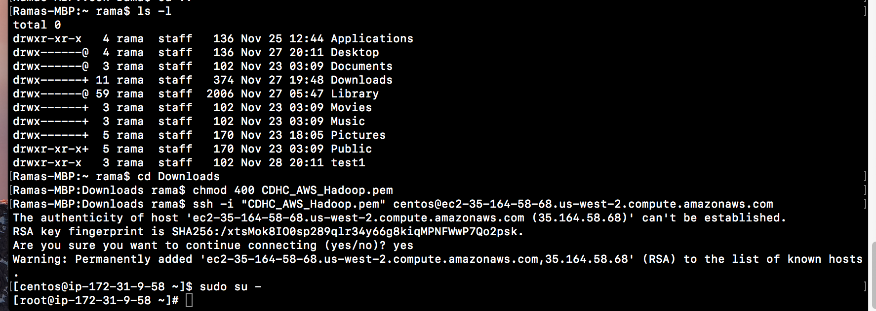

****************** Connecting servers successfully completed *************

**Part#2 DISK PARTITIONS**

Purpose:   
For complete utilization of memory selected in AWS, following steps show redefine selected space on all servers

1. Go to NAMENODE server 172.31.9.58 in Terminal, and follow below steps for complete memory allocation

 Disk setting before change, and UNIX commands used are:  
 df -h  
 fdisk-l

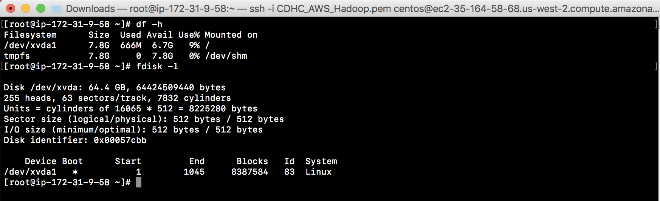

1. Follow below commands to use redefine memory settings:
   1. fdisk /dev/xvda

|  |  |  |
| --- | --- | --- |
| Command: | u | Display/entry units in sectors |
|  | p | partition |
|  | d | Delete current partition |
|  | n | Create new partition |
|  | p |  |
|  | 1 | Select Partition 1 |
|  | 2048 | Select sector |
|  | p | verify |
|  | a | Append |
|  | w | Write partition |

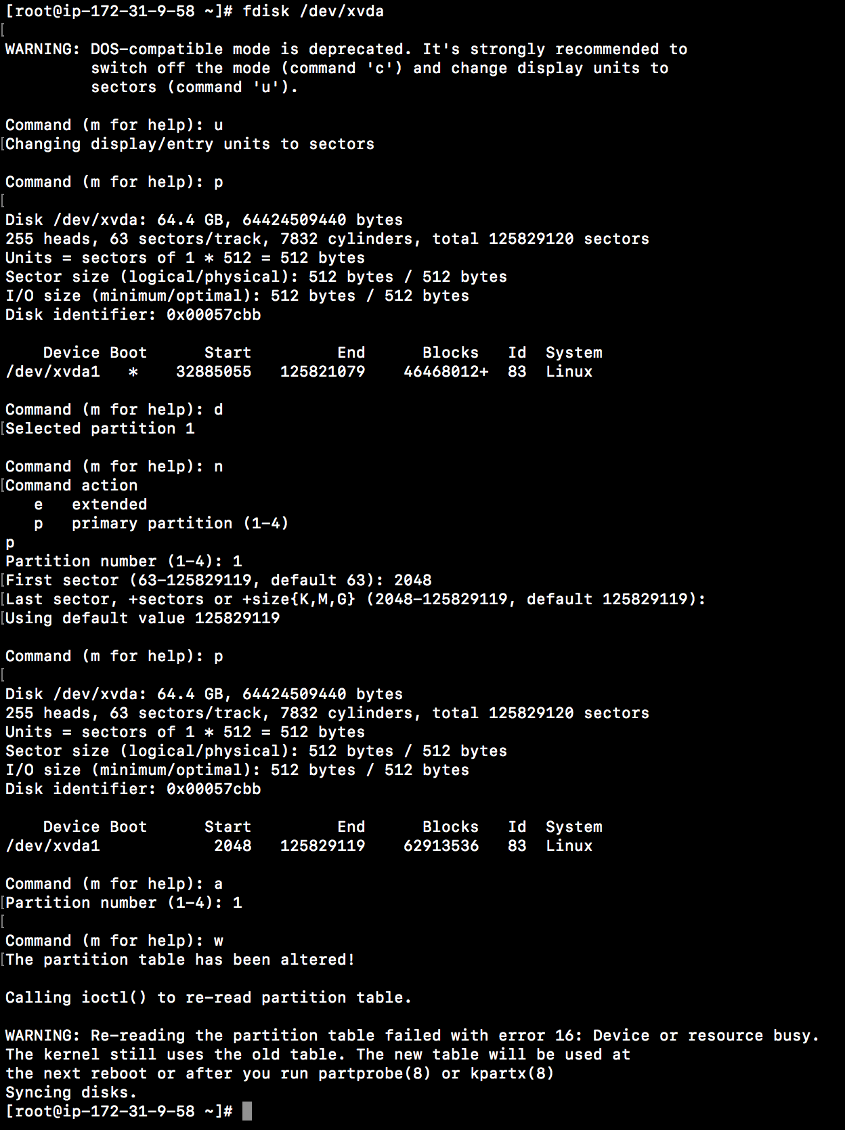

1. Repeat the above process for remaining two servers:  
   172.31.9.59 and 172.31.9.60
2. Stop and restart servers in AWS instance window  
   Stop servers:

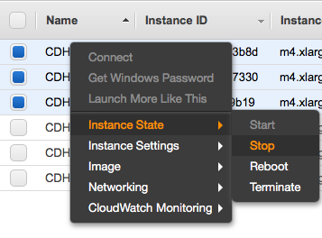

Restart servers:

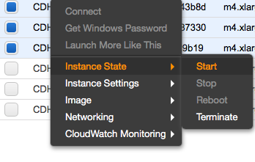

1. Verify this task is successful by connecting to servers in their respective Terminal window

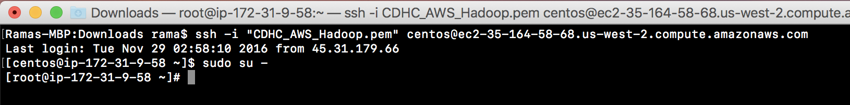

1. Verify disk

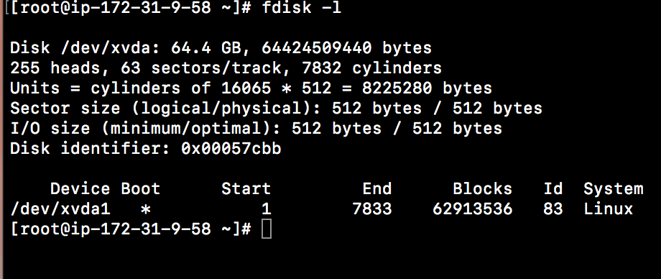

******** Disk partition completed, and successful start & restart of servers************

1. **Part#3 SERVER UPDATES**Installing update in servers   
   (Below example is shown for namenode server. Similar steps need to be repeated for other servers as well)

sudo yum -y update;sudo yum -y install telnet;sudo yum -y install httpd;sudo yum -y install iptables-services



 Updates completed:

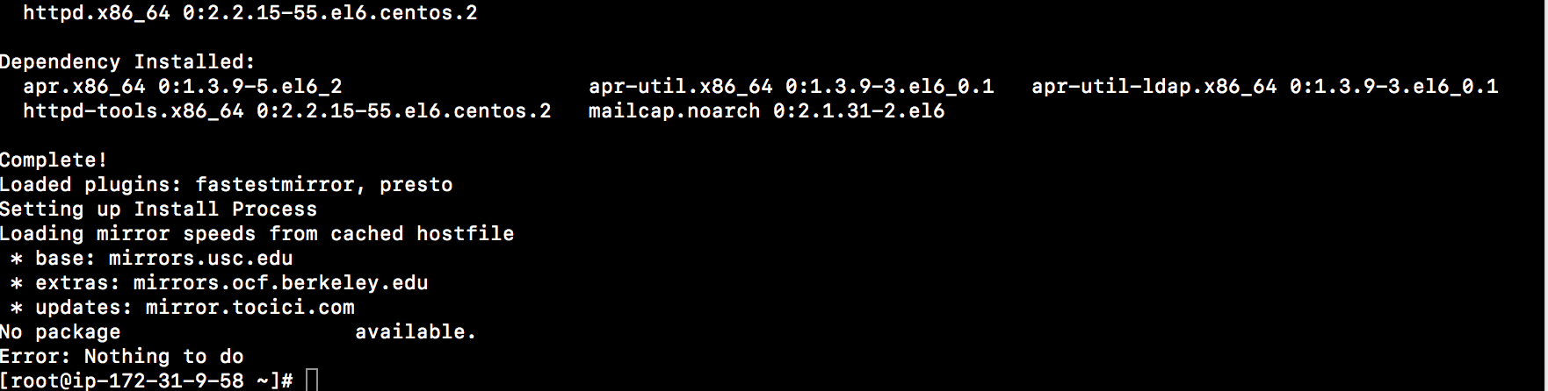



HOSTNAMES:  
**Public DNS ec2-35-164-58-68.us-west-2.compute.amazonaws.com**  
Accessible and communicating with public internet and intranet

**Private DNS ip-172-31-9-58.us-west-2.compute.internal  
(Private DNS is required in host for internal communication of clusters  
 It is also known as "FQDN" = Fully Qualified Domain Name)**

In each server terminal window, go to  
vi /etc/sysconfig/network



And change Hostname from

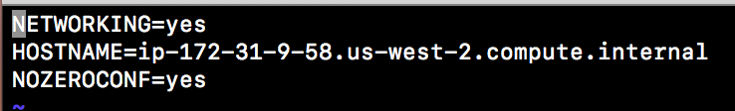

to

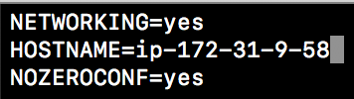

1. Change nameserver in 'resolv.config' file to their respective IP addresses



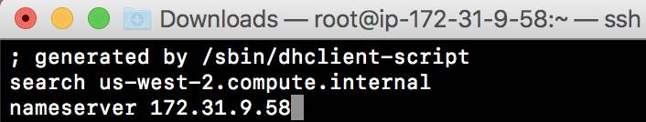

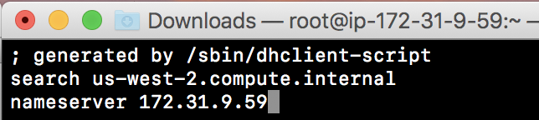

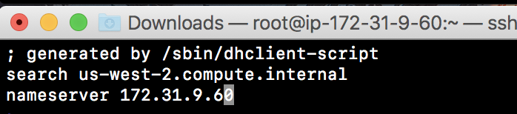

1. Update all Private DNS of servers in hosts file

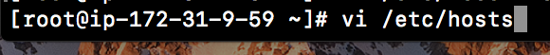

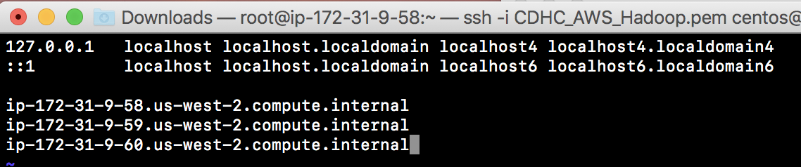

1. Repeat this above servers on other two servers
2. Stop and restart servers in AWS instance window  
   Stop servers:



Restart servers:



1. Verify this task is successful by connecting to servers in their respective Terminal window



1. Verify hostname in terminal for each server

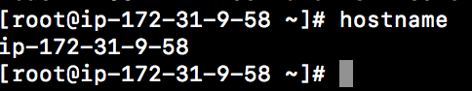

**Part#4 SELINUX**

1. Follow below steps to 'disabled' Selinux firewall on each server



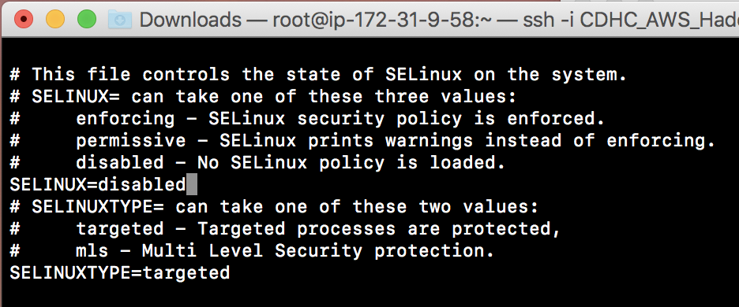

1. Turn off Iptables when servers is restared:  
   sudo chkconfig iptables off;sudo service iptables stop



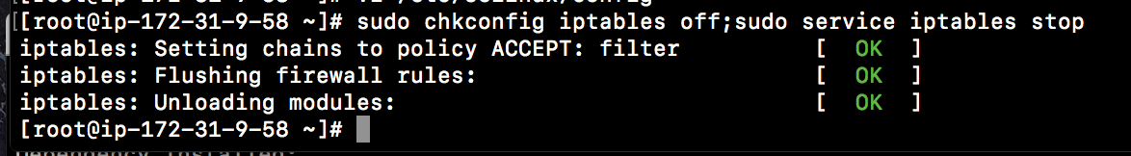

Repeat above to all servers

1. Stop and restart servers in AWS instance window  
   Stop servers:



Restart servers:



1. Verify this task is successful by connecting to servers in their respective Terminal window



**Part#4 KEYPAIR CREATION**

* 1. Create a group "hadoopthoughtworks", and user thoughtworks" in that group

sudo groupadd hadoopthoughtworks;sudo useradd thoughtworks -g hadoopthoughtworks

Create above group and user in all servers

* 1. Create no password requirement for user"thoughtworks" in group>  
     Complete below step for all servers

sudo visudo

## Same thing without a password

# %wheel        ALL=(ALL)       NOPASSWD: ALL

thoughtworks    ALL=(ALL)       NOPASSWD: ALL

* 2. Enter below command to be present in user directory.  
     This is critical as as SSH will be created in this directory

[root@ip-172-31-9-58 ~]# sudo su - thoughtworks

[thoughtworks@ip-172-31-9-58 ~]$

* 1. KEYGEN creation in NAMENODE:  
     Generat keygen in ssh directory, verify files are created  
     [thoughtworks@ip-172-31-9-58 ~]$ ssh-keygen

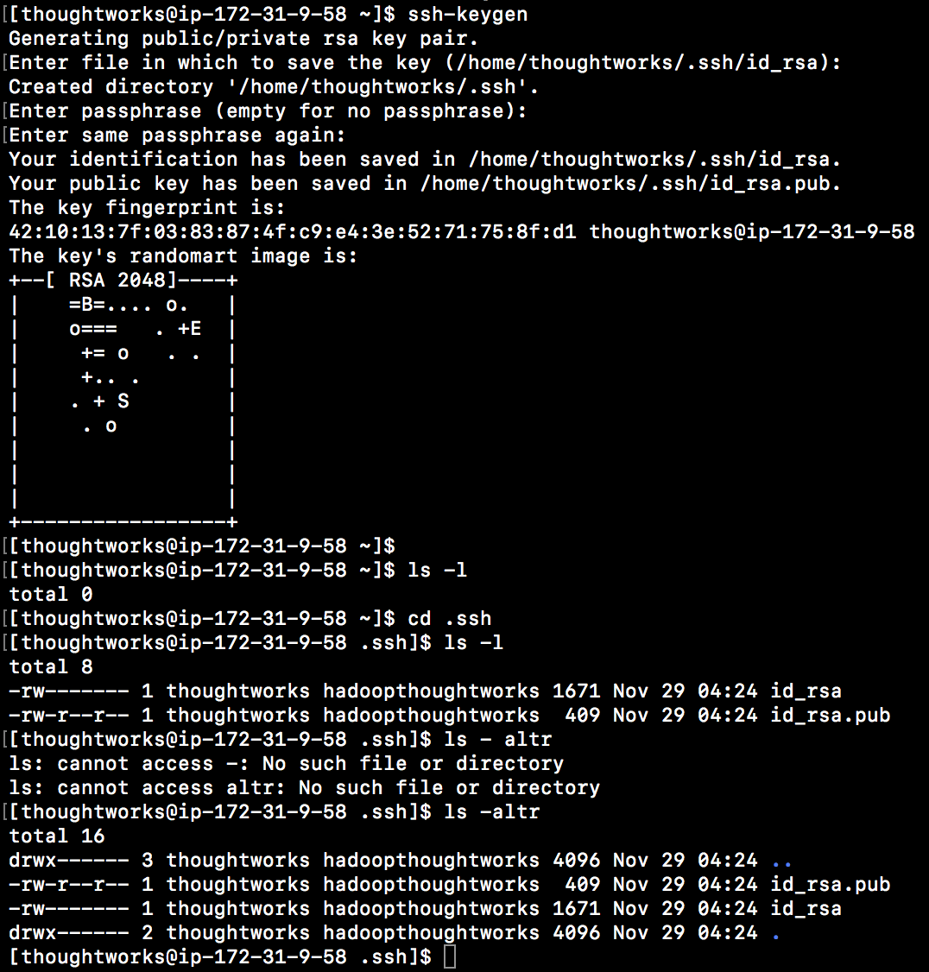

SSH directory and files id_rsa and id_rsa.pub are created by an utility known as "Keygen"  
This is created in NAMENODE server only.  
Keys created in this NAMENODE server are copied to other servers.  
To align permission between these servers, chmod is required to be changed manually as below.  
Needs to be completed in all servers  
[thoughtworks@ip-172-31-9-58 .ssh]$ mkdir .ssh;chmod 700 .ssh

* 1. Copy 'id_rsa' token in Namenode, and paste it in all datanodes or other servers

[thoughtworks@ip-172-31-9-58 .ssh]$ cat id_rsa

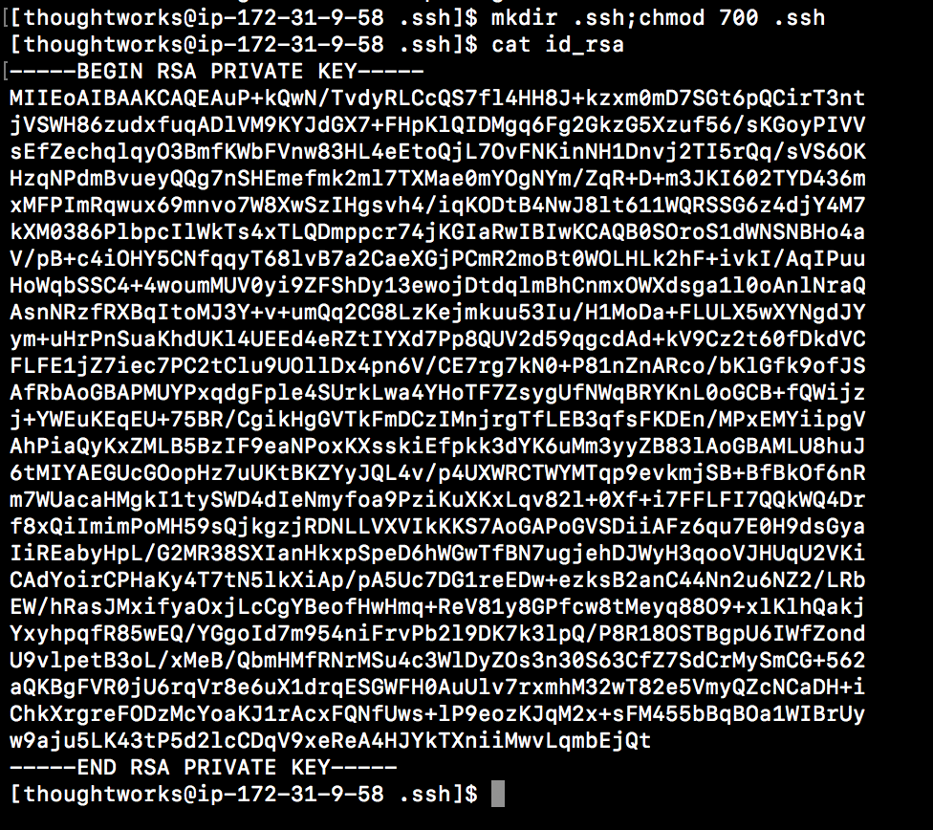

Copy above RSA PRIVATE Key and save it in other servers  
If needed, create a file name 'id_rsa' in .ssh directory and save above private key



Should have equal permissions for all datanodes

[thoughtworks@ip-172-31-9-59 ~]$ chmod 600 .ssh/id_rsa

[thoughtworks@ip-172-31-9-59 ~]$

* 1. Copy 'id_rsa' public key from NAMENODE to all datanodes, and change their respective IP addresses at the end  
     Create a new file 'id_rsa.pub' in all datanodes, and paste the key copied   
       
     Namenode:

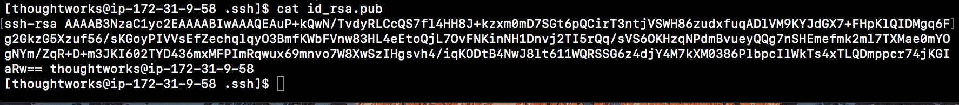

id_rsa.pub key verification after copying:

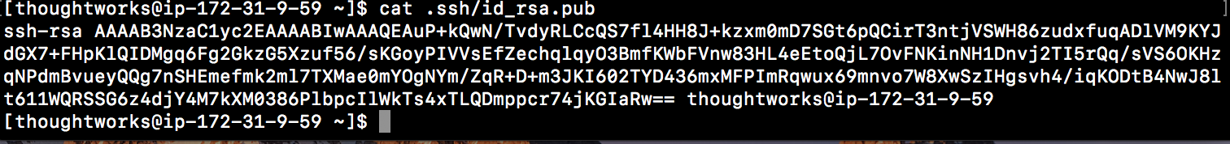



* 1. Create an authorized_keys file in Namenode

[thoughtworks@ip-172-31-9-58 .ssh]$ cp id_rsa.pub authorized_keys

[thoughtworks@ip-172-31-9-58 .ssh]$ vi authorized_keys

Copy id_rsa_pub key and define IP address of nodes in "authorized_keys" file

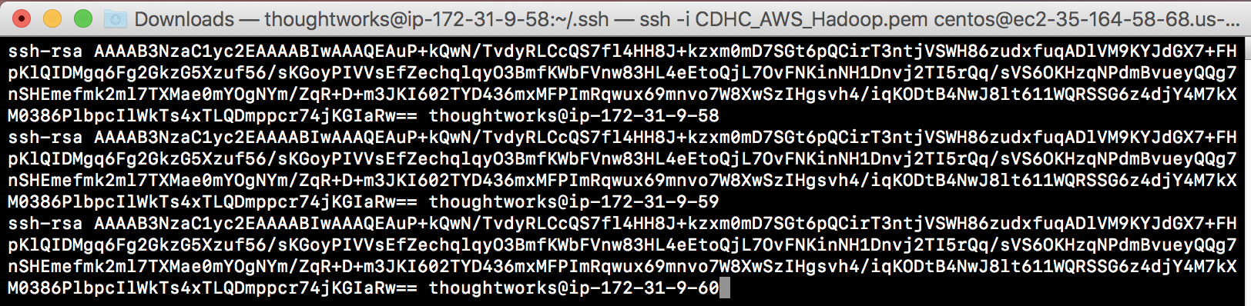

Verify authorized_keys file in namenode server

[thoughtworks@ip-172-31-9-58 .ssh]$ ls

authorized_keys  id_rsa  id_rsa.pub

[thoughtworks@ip-172-31-9-58 .ssh]$

Create "authorized_keys" file in other servers i.e.172-31-9-59, and 172-31-9-60

[thoughtworks@ip-172-31-9-59 .ssh]$ ls

authorized_keys  id_rsa  id_rsa.pub

[thoughtworks@ip-172-31-9-60 .ssh]$ ls

authorized_keys  id_rsa  id_rsa.pub

* 1. Testing if this works:  
     Go to home directory, and go to localhost to confirm RSA is key is added  
     Exit the namenode server

[thoughtworks@ip-172-31-9-58 .ssh]$ cd ~

[thoughtworks@ip-172-31-9-58 ~]$ ssh thoughtworks@localhost

The authenticity of host 'localhost (::1)' can't be established.

RSA key fingerprint is b8:8f:35:2b:c8:a1:2b:3c:d4:08:31:bd:e6:51:5a:20.

Are you sure you want to continue connecting (yes/no)? yes

Warning: Permanently added 'localhost' (RSA) to the list of known hosts.

[thoughtworks@ip-172-31-9-58 ~]$ exit

logout

Connection to localhost closed.

Test if login works for other servers

[thoughtworks@ip-172-31-9-58 ~]$ ssh thoughtworks@172.31.9.59

The authenticity of host '172.31.9.59 (172.31.9.59)' can't be established.

RSA key fingerprint is c9:9f:a0:74:bb:4a:1a:ea:ac:af:c5:3d:bf:4e:1a:50.

Are you sure you want to continue connecting (yes/no)? yes

Warning: Permanently added '172.31.9.59' (RSA) to the list of known hosts.

[thoughtworks@ip-172-31-9-59 ~]$ exit

logout

Connection to 172.31.9.59 closed.

[thoughtworks@ip-172-31-9-58 ~]$ ssh thoughtworks@172.31.9.60

The authenticity of host '172.31.9.60 (172.31.9.60)' can't be established.

RSA key fingerprint is 97:b1:3d:72:e1:77:d2:90:35:62:59:09:b2:d8:b6:bf.

Are you sure you want to continue connecting (yes/no)? yes

Warning: Permanently added '172.31.9.60' (RSA) to the list of known hosts.

[thoughtworks@ip-172-31-9-60 ~]$ exit

logout

Connection to 172.31.9.60 closed.

Seamless and Password less communication has been established between all the servers.

* 1. Install wget. It is an utility that installs file for the user  
     [thoughtworks@ip-172-31-9-58 ~]$ sudo yum -y install wget  
     .  
     .  
     .

Running Transaction

  Installing : wget-1.12-8.el6.x86_64                                                                         1/1

  Verifying  : wget-1.12-8.el6.x86_64                                                                         1/1

Installed:

  wget.x86_64 0:1.12-8.el6

Complete!

[thoughtworks@ip-172-31-9-58 ~]$

Installing cloudera manager  
[thoughtworks@ip-172-31-9-58 ~]$ sudo wget <http://archive-primary.cloudera.com/cm5/installer/latest/cloudera-manager-installer.bin>

Verify that .bin file is downloaded, and  
give execute permission to install

[thoughtworks@ip-172-31-9-58 ~]$ ls

cloudera-manager-installer.bin

[thoughtworks@ip-172-31-9-58 ~]$ sudo chmod u+x ./cloudera-manager-installer.bin

[thoughtworks@ip-172-31-9-58 ~]$ sudo ./cloudera-manager-installer.bin

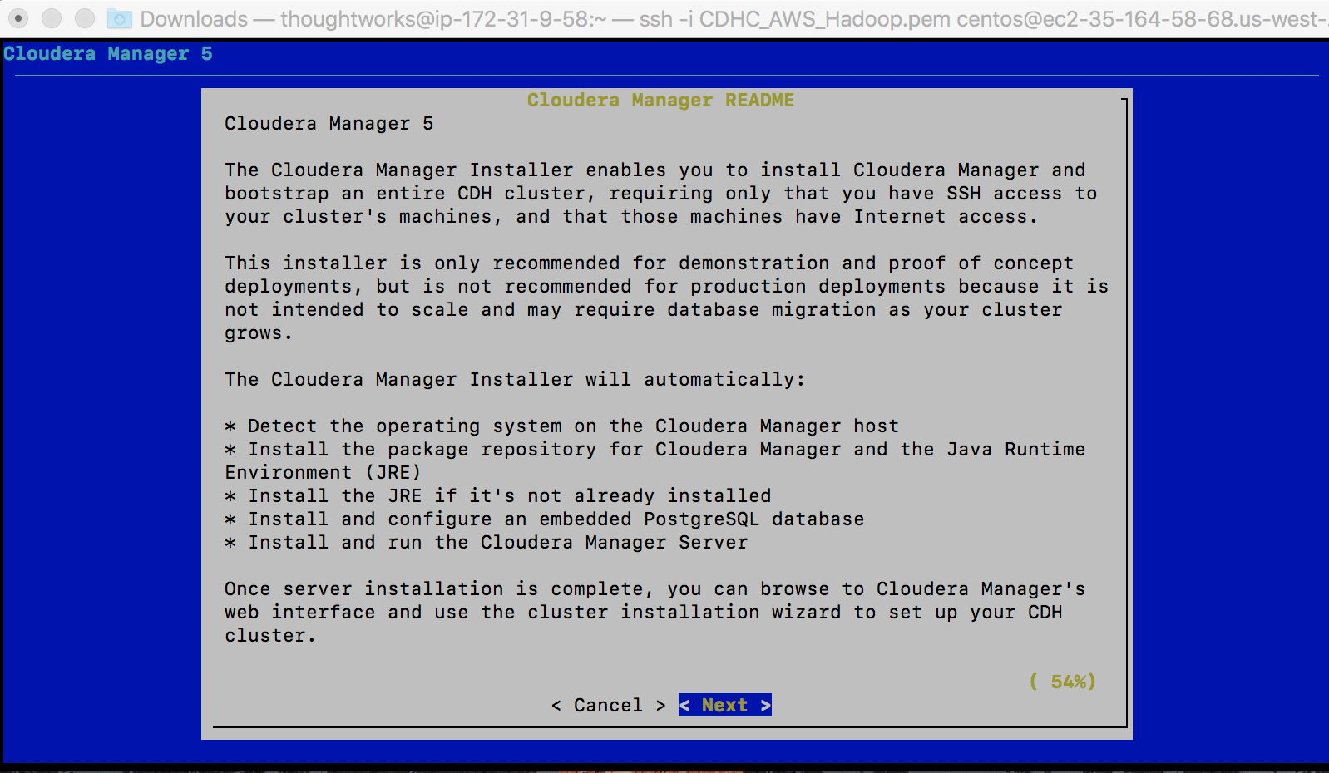

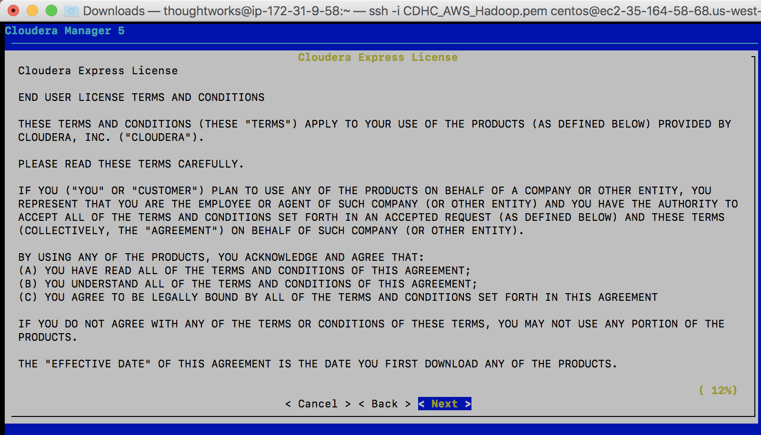

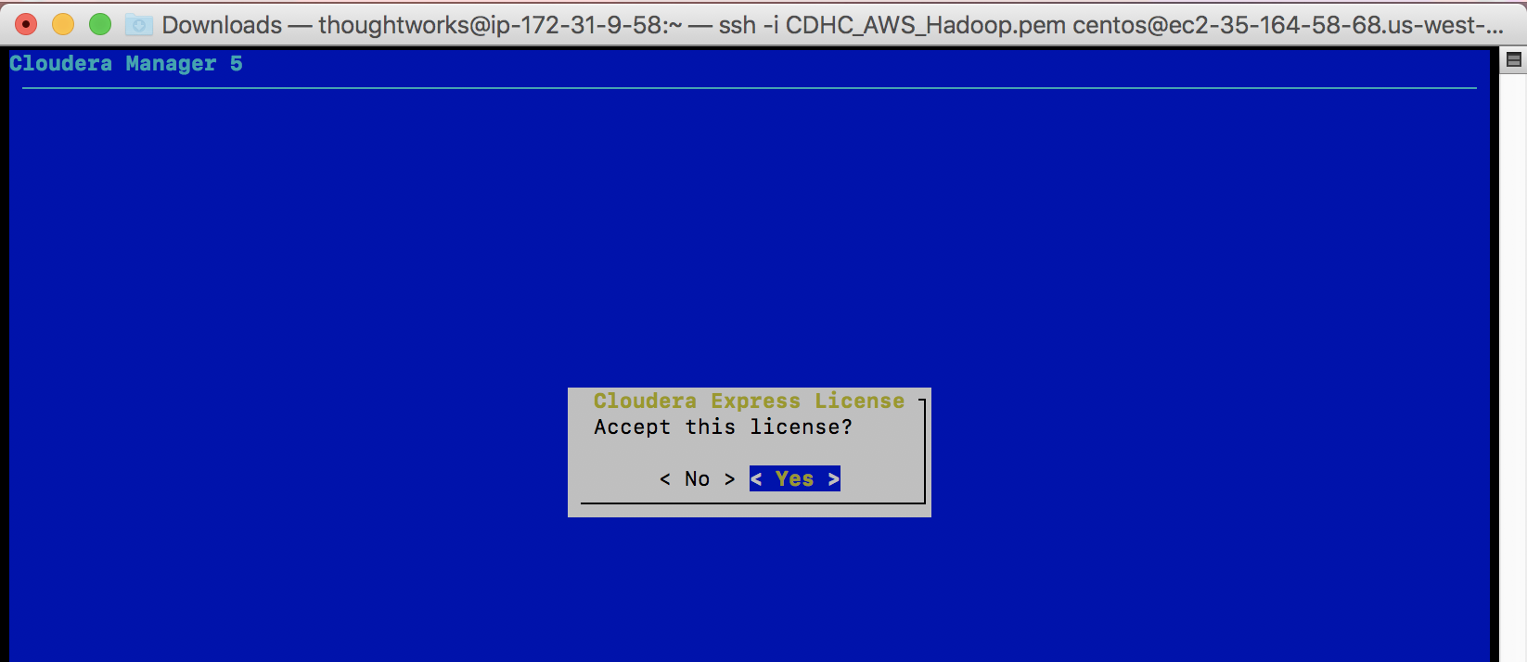

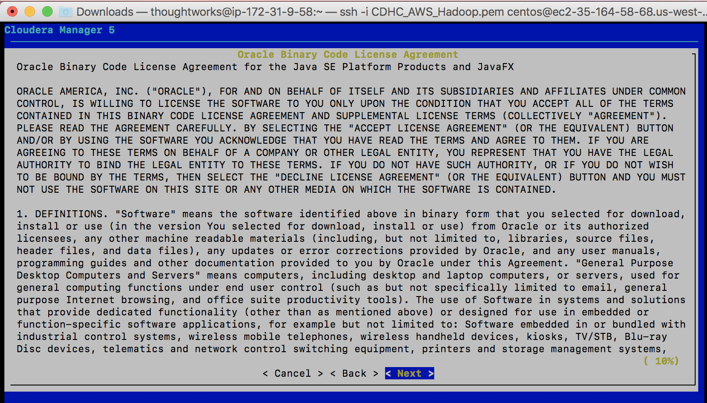

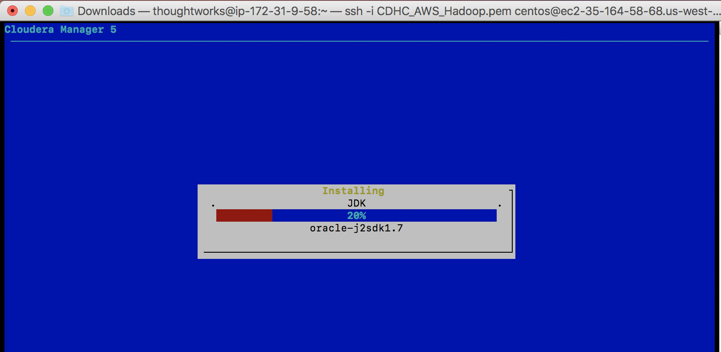

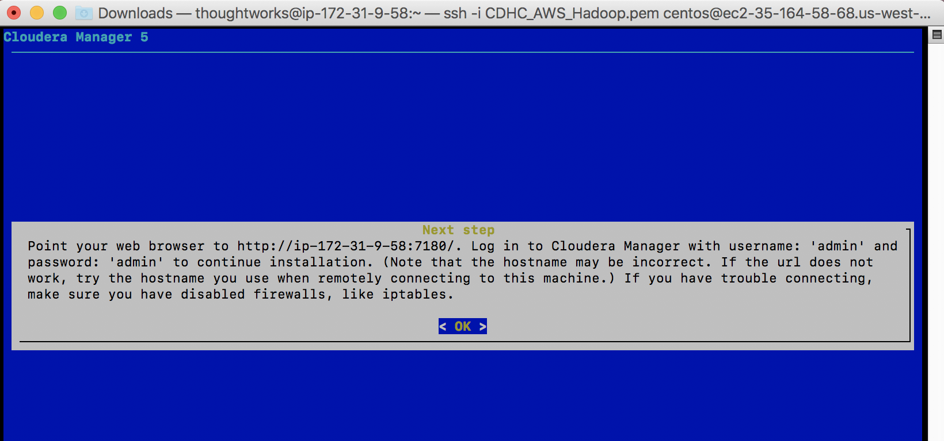

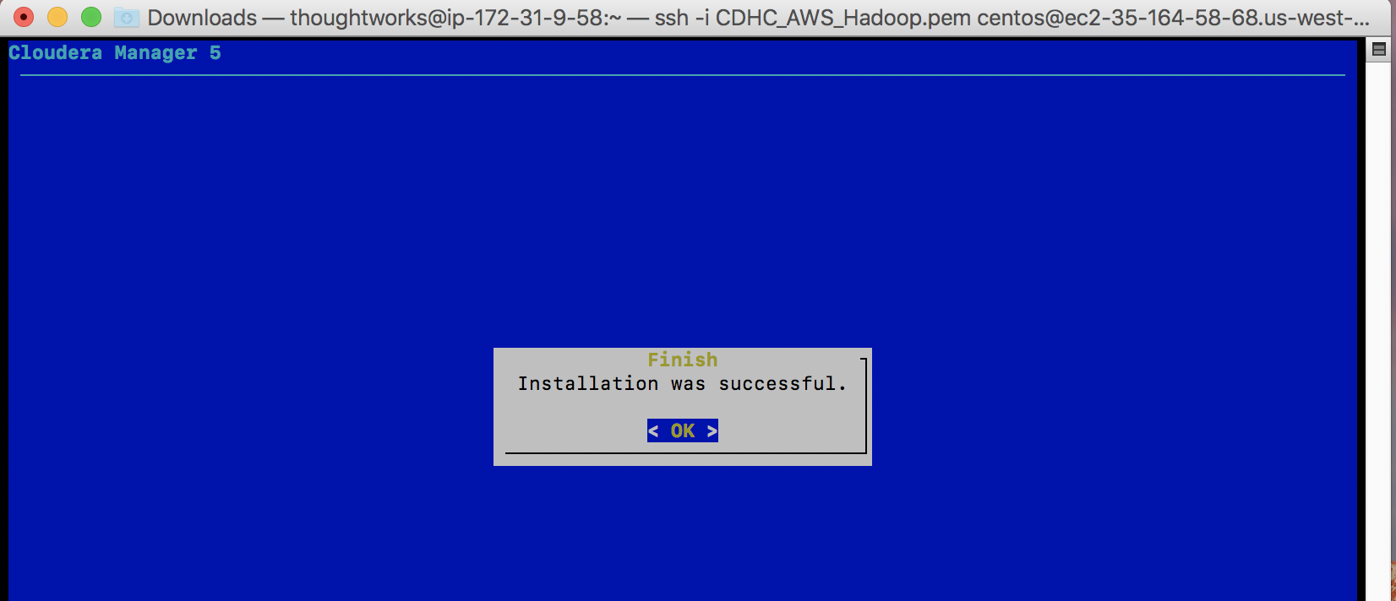

* 1. Go to root directory, and vi the file /etc/cloudera-scm-server/db.mgmt.properties, and   
     change the Fully Qualified Doman Name address to hostname.   
       
     **Before change**

[thoughtworks@ip-172-31-9-58 ~]$ sudo su -

[root@ip-172-31-9-58 ~]# cat /etc/cloudera-scm-server/db.mgmt.properties

# Auto-generated by initialize_embedded_db.sh

#

# 20161201-033857

#

# These are database credentials for databases

# created by "cloudera-scm-server-db" for

# Cloudera Manager Management Services,

# to be used during the installation wizard if

# the embedded database route is taken.

#

# The source of truth for these settings

# is the Cloudera Manager databases and

# changes made here will not be reflected

# there automatically.

#

com.cloudera.cmf.ACTIVITYMONITOR.db.type=postgresql

com.cloudera.cmf.ACTIVITYMONITOR.db.host=ip-172-31-9-58.us-west-2.compute.internal:7432

com.cloudera.cmf.ACTIVITYMONITOR.db.name=amon

com.cloudera.cmf.ACTIVITYMONITOR.db.user=amon

com.cloudera.cmf.ACTIVITYMONITOR.db.password=ui3xmkhUsF

com.cloudera.cmf.REPORTSMANAGER.db.type=postgresql

com.cloudera.cmf.REPORTSMANAGER.db.host=ip-172-31-9-58.us-west-2.compute.internal:7432

com.cloudera.cmf.REPORTSMANAGER.db.name=rman

com.cloudera.cmf.REPORTSMANAGER.db.user=rman

com.cloudera.cmf.REPORTSMANAGER.db.password=PMDiHuD4RI

com.cloudera.cmf.NAVIGATOR.db.type=postgresql

com.cloudera.cmf.NAVIGATOR.db.host=ip-172-31-9-58.us-west-2.compute.internal:7432

com.cloudera.cmf.NAVIGATOR.db.name=nav

com.cloudera.cmf.NAVIGATOR.db.user=nav

com.cloudera.cmf.NAVIGATOR.db.password=DBmdzd2otA

com.cloudera.cmf.NAVIGATORMETASERVER.db.type=postgresql

com.cloudera.cmf.NAVIGATORMETASERVER.db.host=ip-172-31-9-58.us-west-2.compute.internal:7432

com.cloudera.cmf.NAVIGATORMETASERVER.db.name=navms

com.cloudera.cmf.NAVIGATORMETASERVER.db.user=navms

com.cloudera.cmf.NAVIGATORMETASERVER.db.password=OoEpJUIkgS

[root@ip-172-31-9-58 ~]#

**After change**

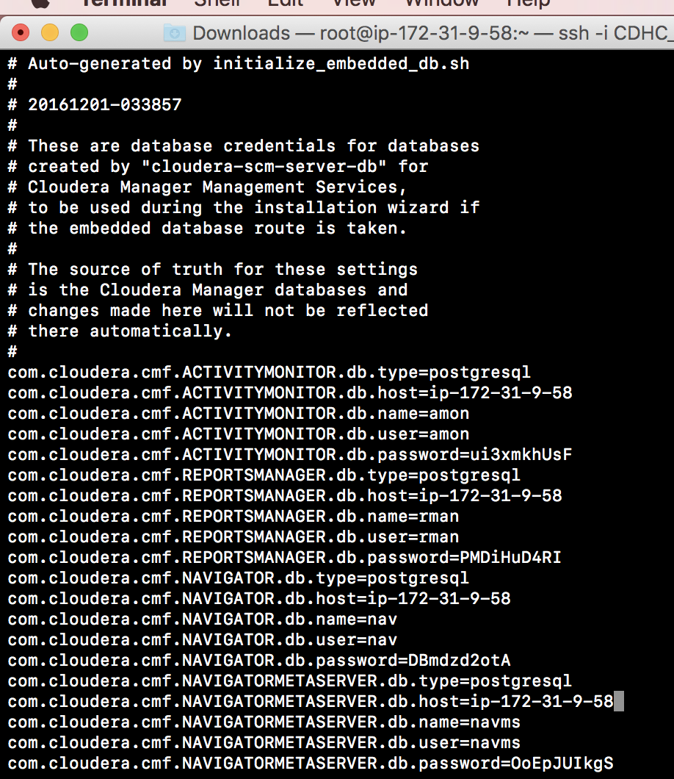

* 1. Go to thoughtworks directory, and complete installation in AWS

**Part#5 HDFS AND YARN Installation**

1. In AWS, Select and copy Public DNS address in Namenode server link:

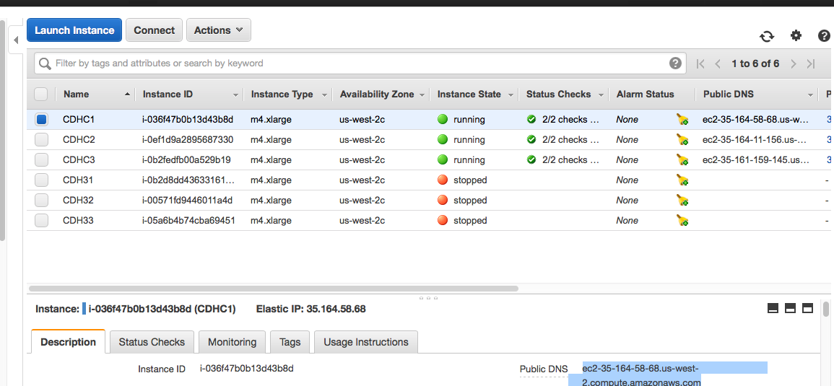

Go to: <http://ec2-35-164-58-68.us-west-2.compute.amazomaws.com:7180>



Username and Password: admin

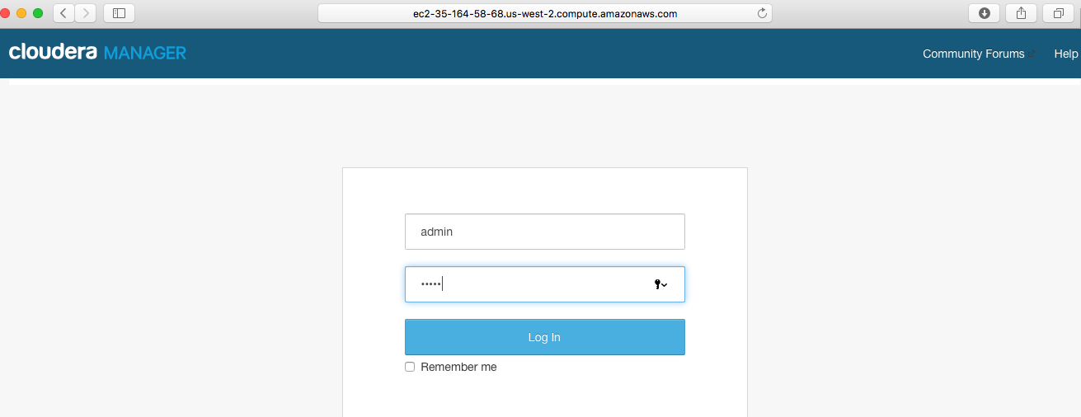

Accept Terms and Conditions

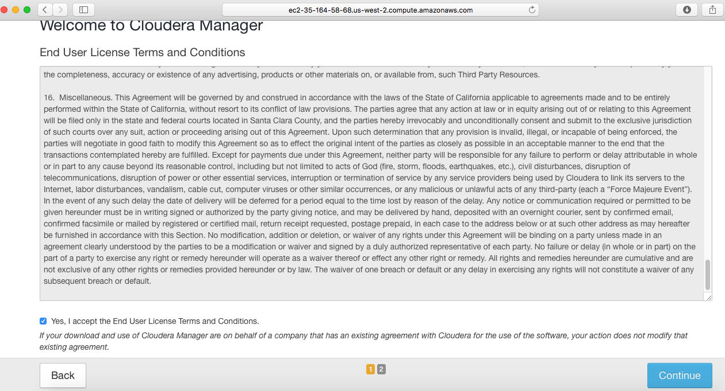

Click Continue

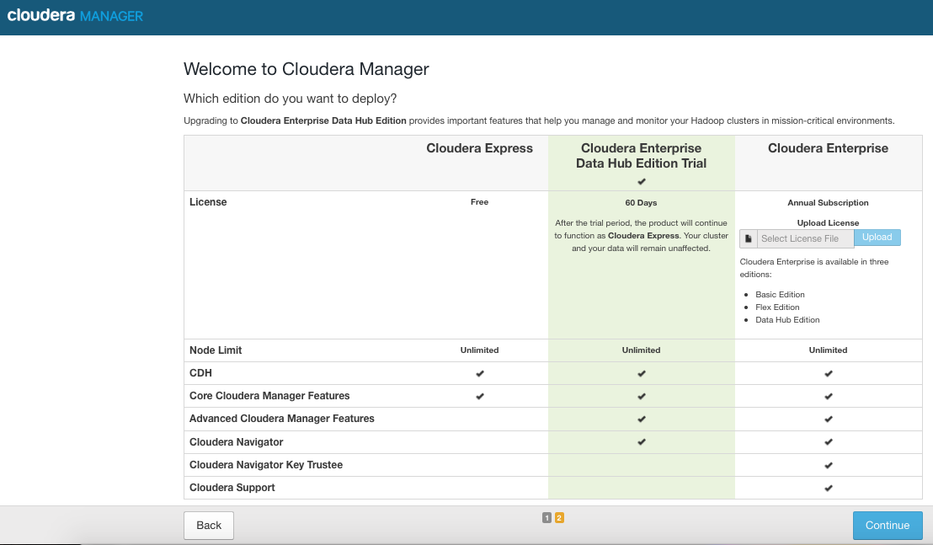

Click Continue

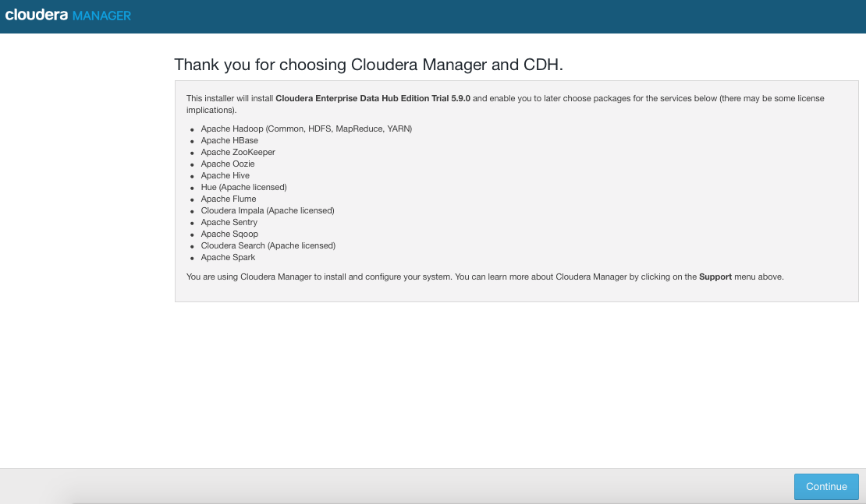

Specify server hostnames, and   
Click Search

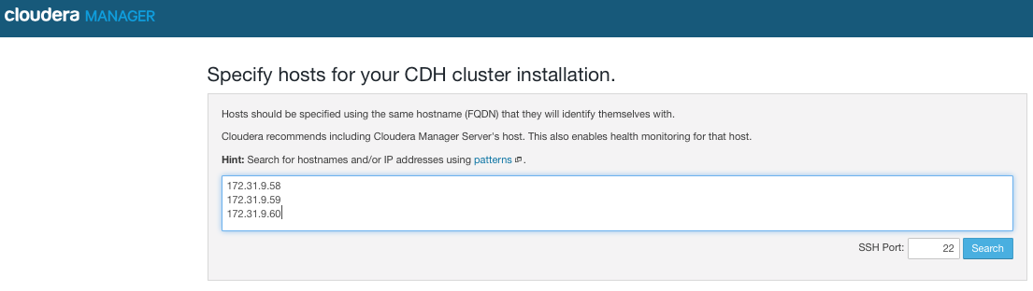

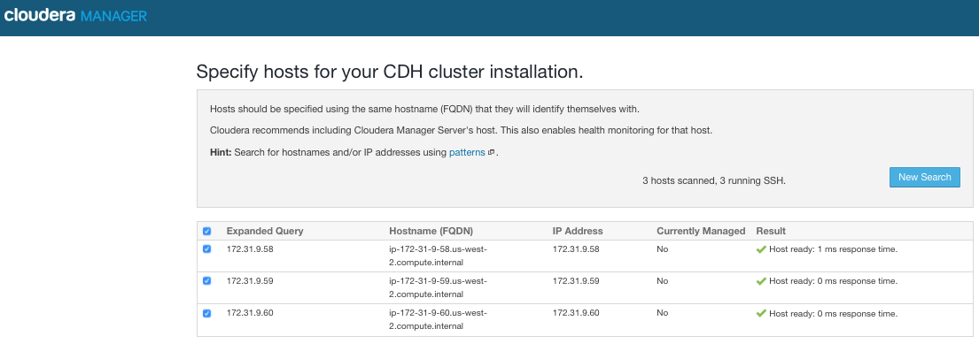

Click Continue

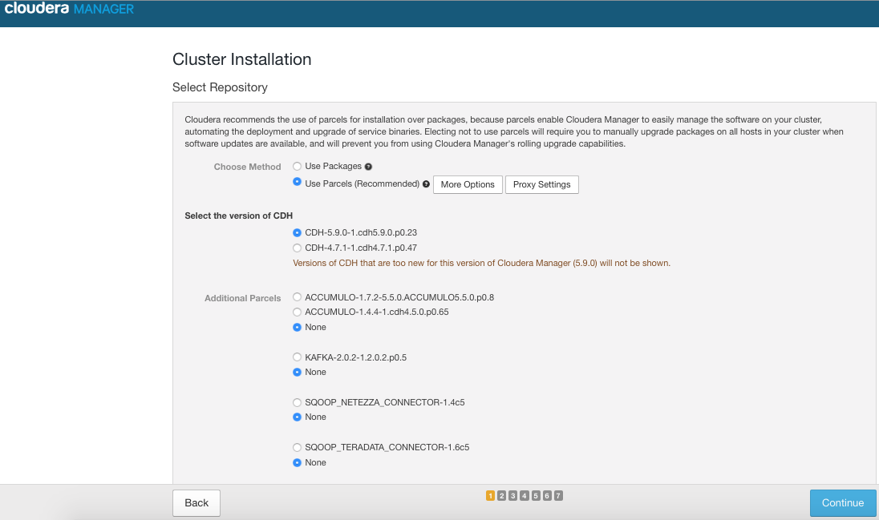

Select Install Oracle Java SE Development Kit, and   
Click Continue

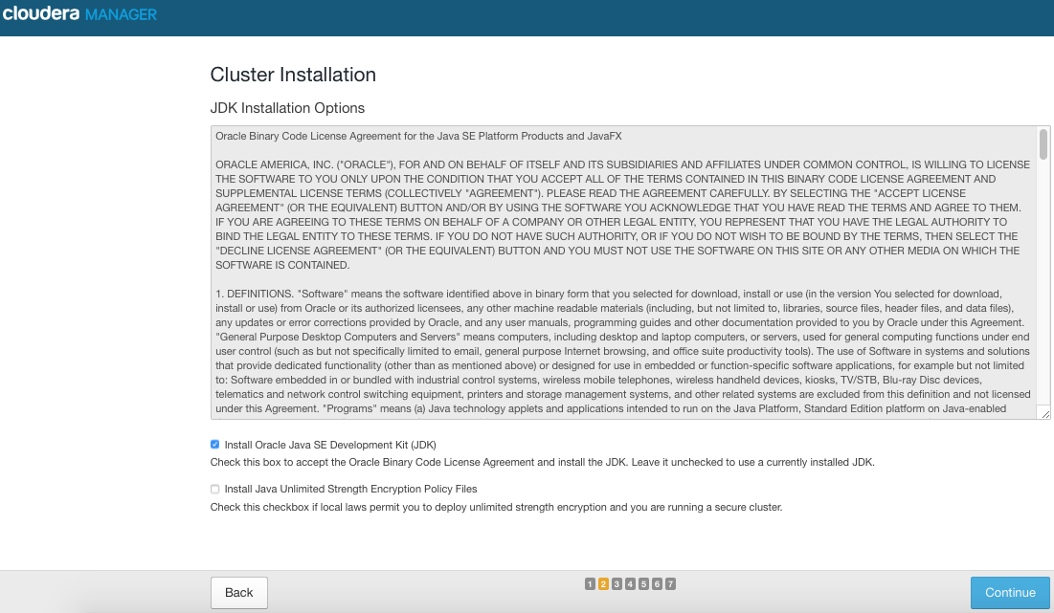

Click Continue

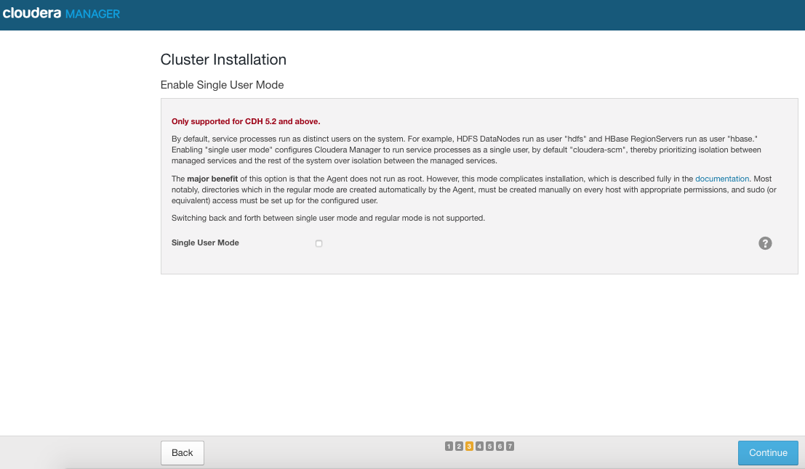

Click Continue

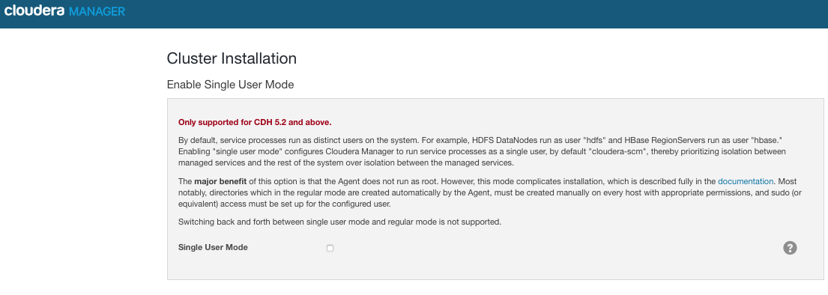

Select user as: thoughtworks  
and upload the id_rsa key to the folder.  
Earlier, seamless and passwordless communication was established between servers.  
This is to have the same with webserver

ID_RSA Filename: Newpass_CDHC_Success.txt

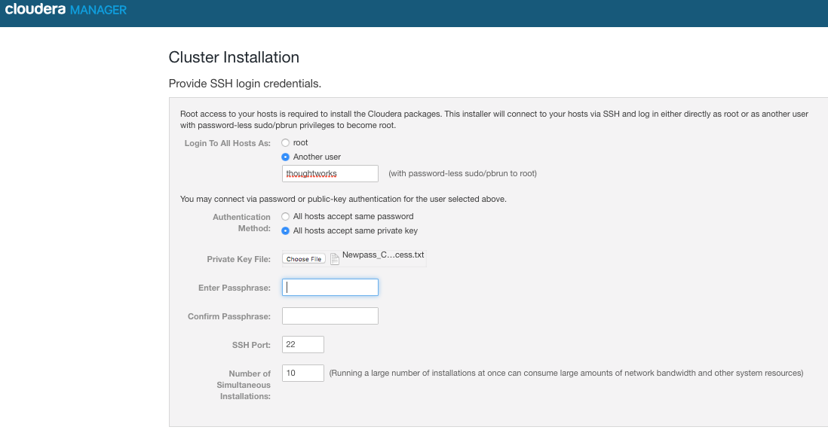

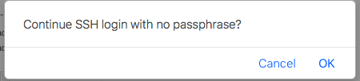

Cluster installation begins

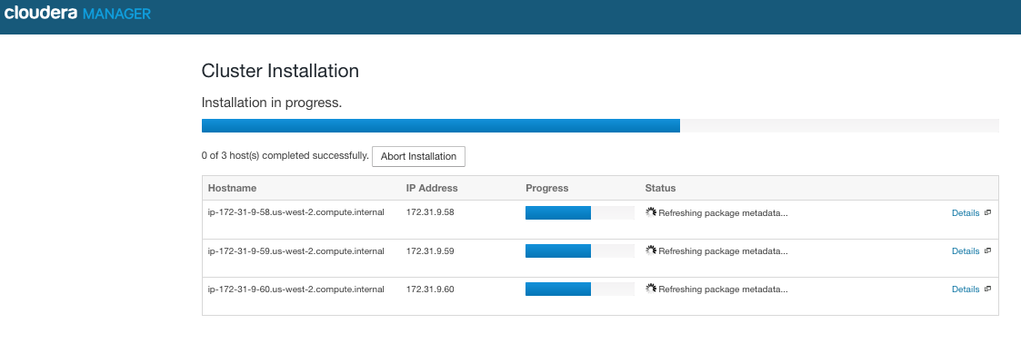

Click Continue after installation

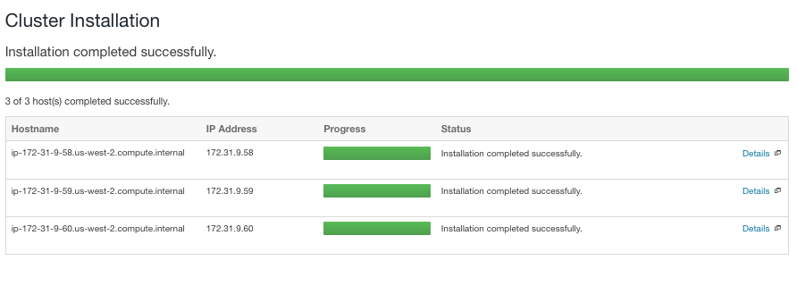

Continue Cluster Installation

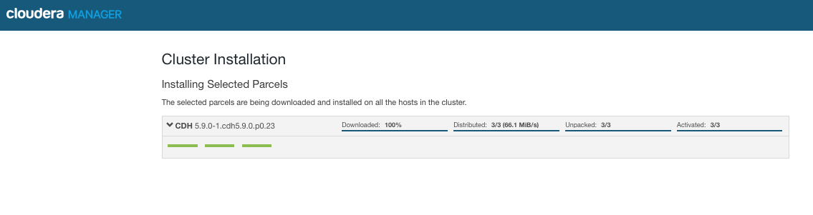

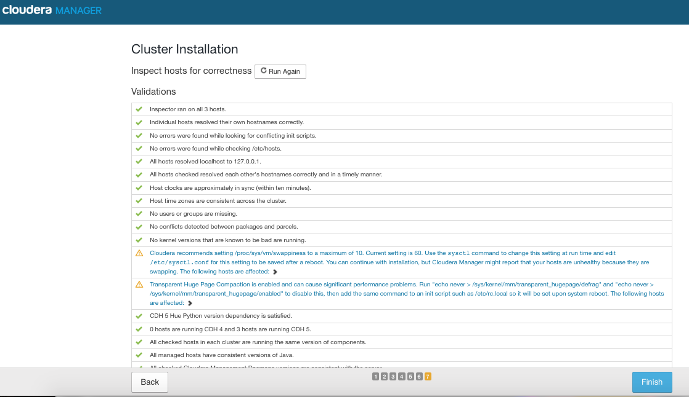

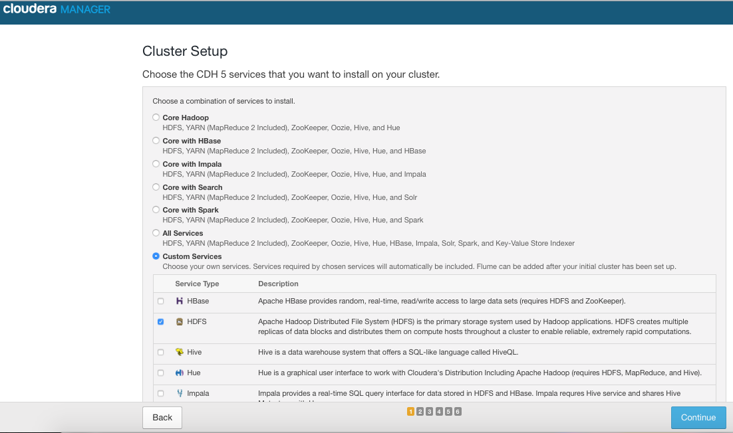

Cluster set-up:  
Assign   
NameNode : 172.31.9.58  
Secondary Namenode : 172.31.9.59  
Activity Monitor as NameNode

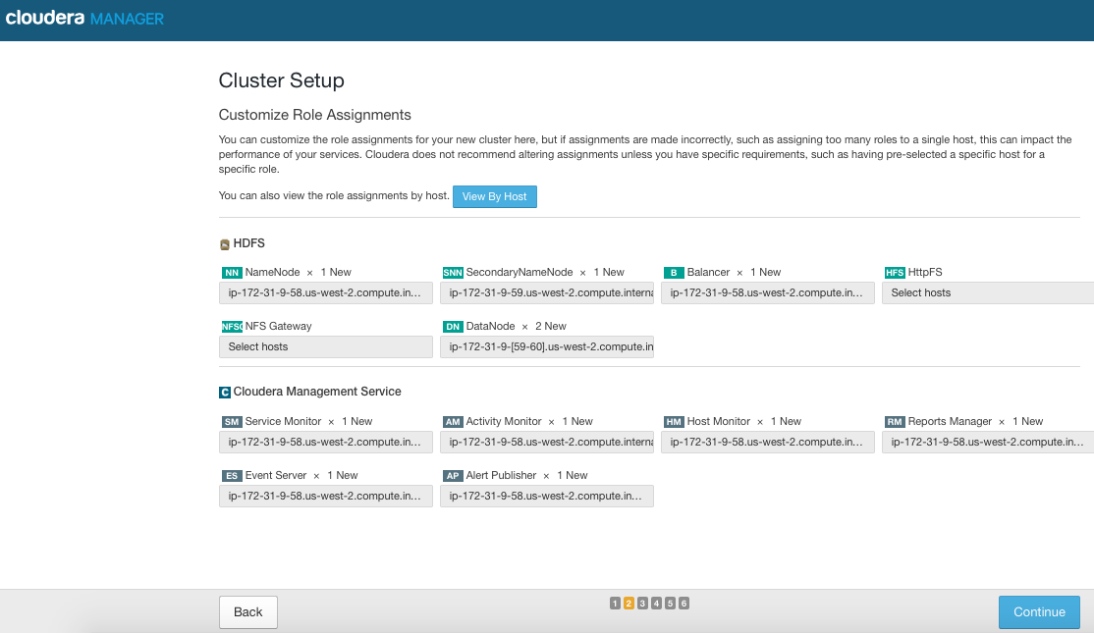

Change to "Use Custom Database", and modify the "Database Hostname" to   
ip-172-31-9-58:7432, and  
Change to "Use Embedded Database", and continue

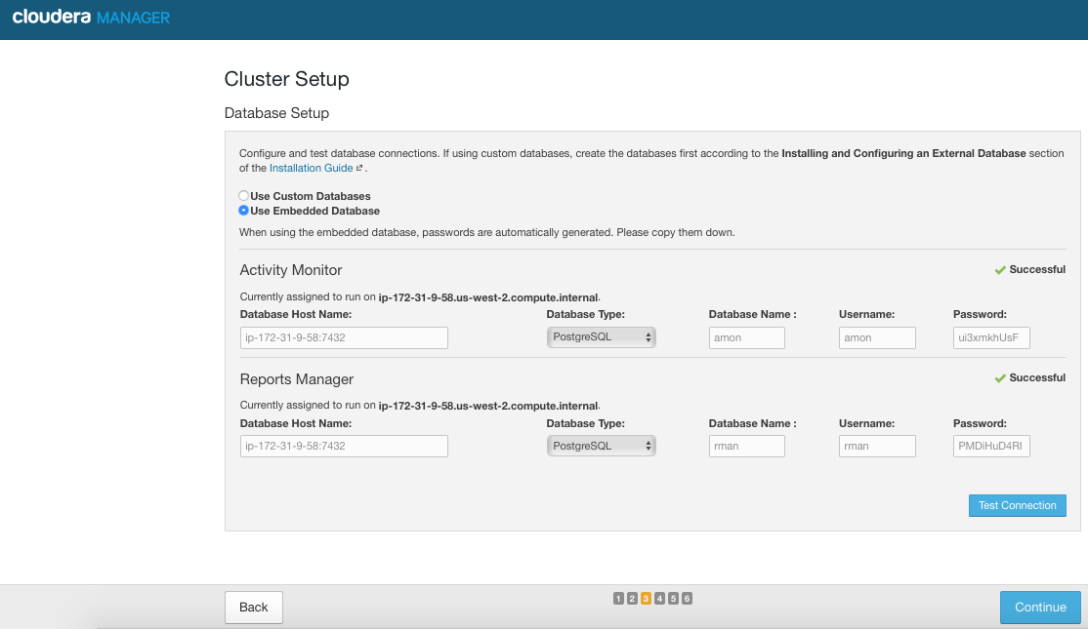

Click Continue

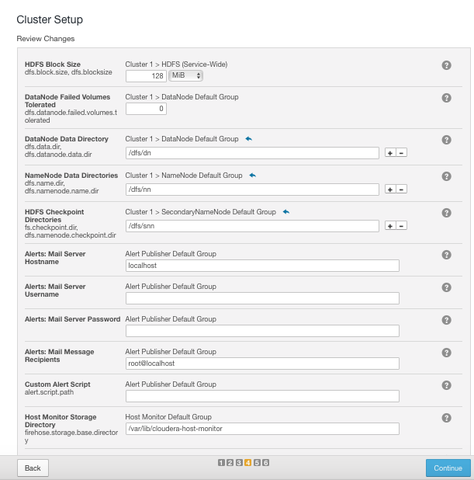

Click Continue

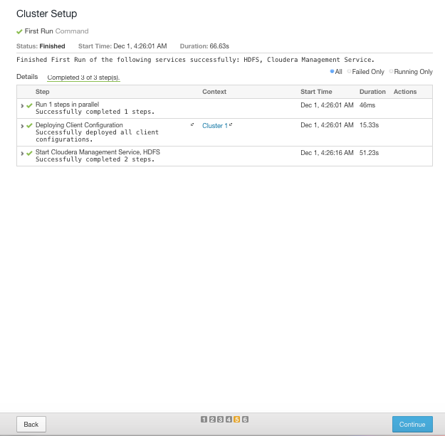

Click FINISH:  
This completes, HDFS cluster set-up

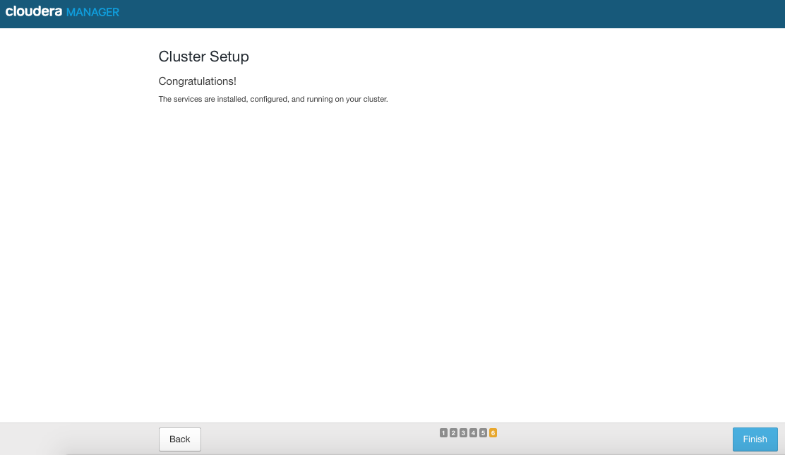

AWS dashboard.

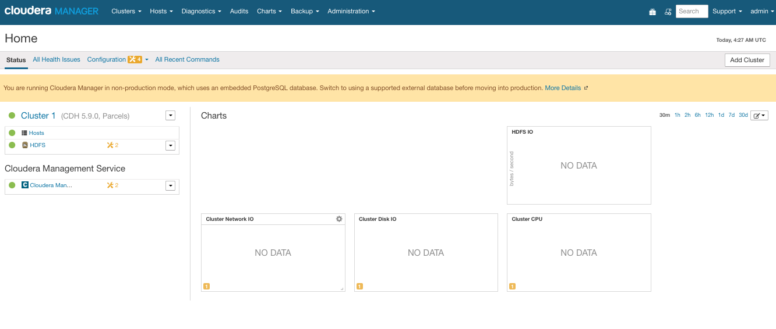

Restart Cluster 1

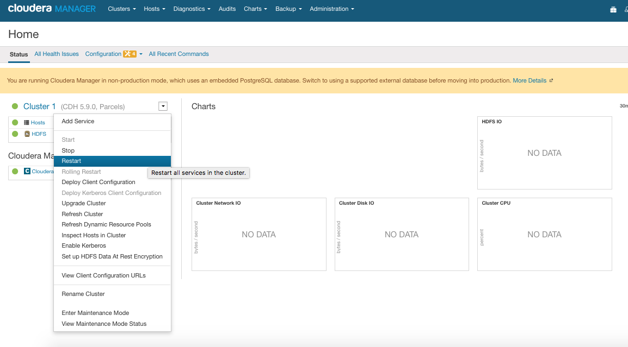

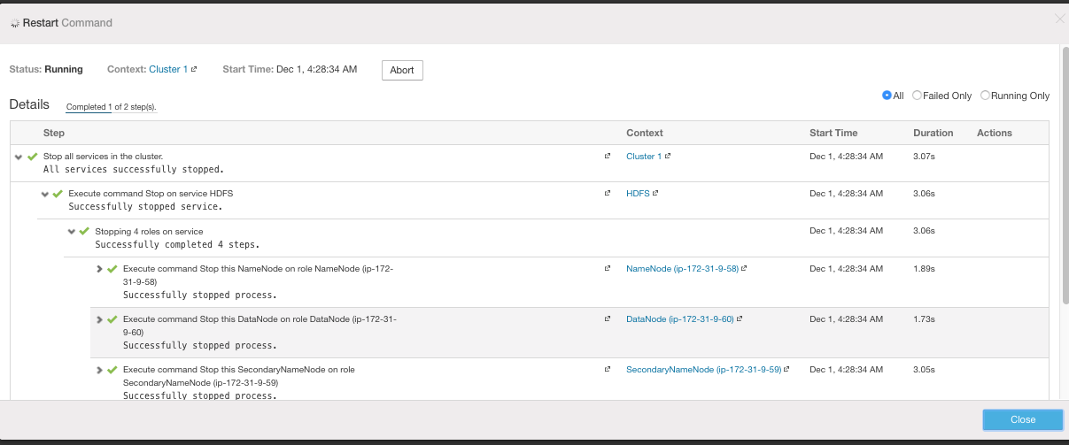

Restart Cloudera Management System

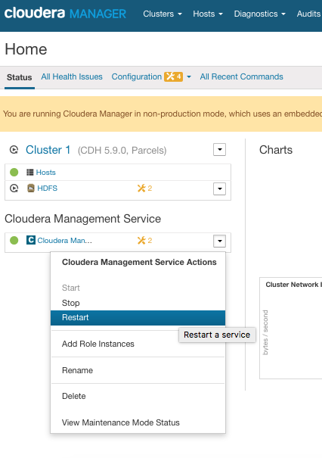

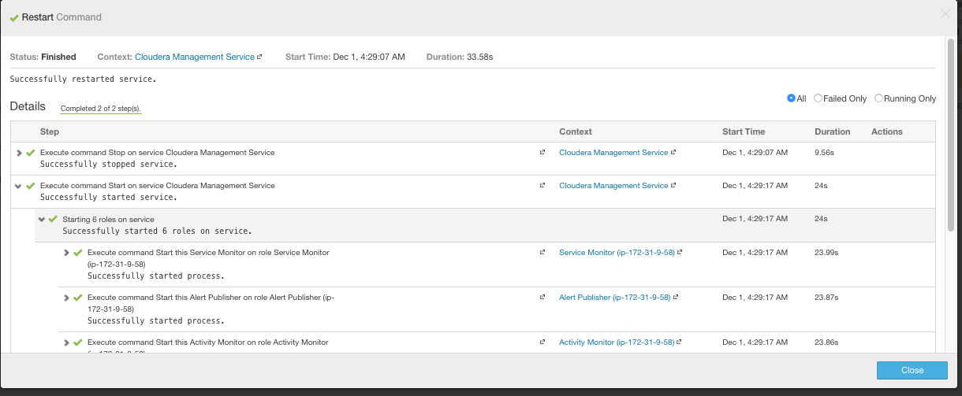



**YARN Installation**

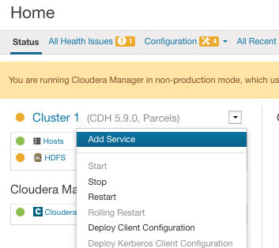

Select YARN

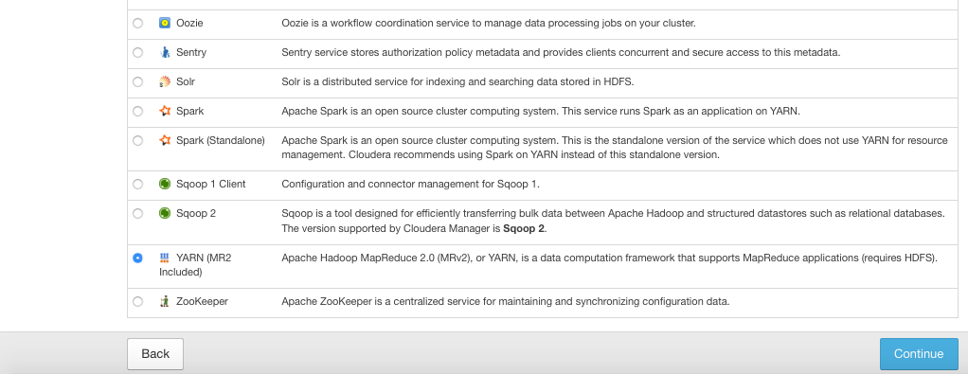

Change JobHistory Server to ip-172-31-9-59

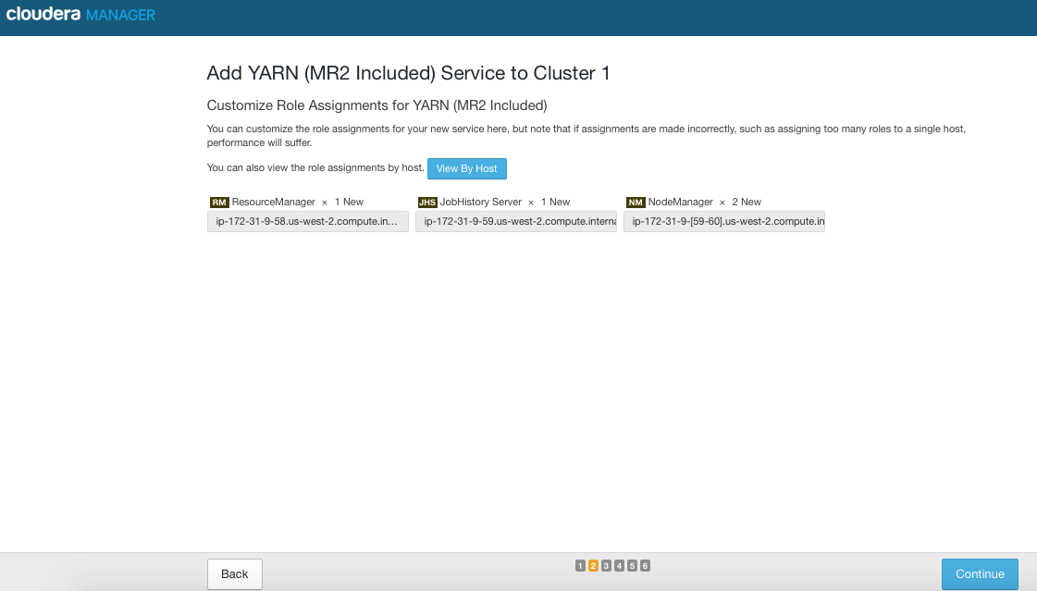

Click Continue

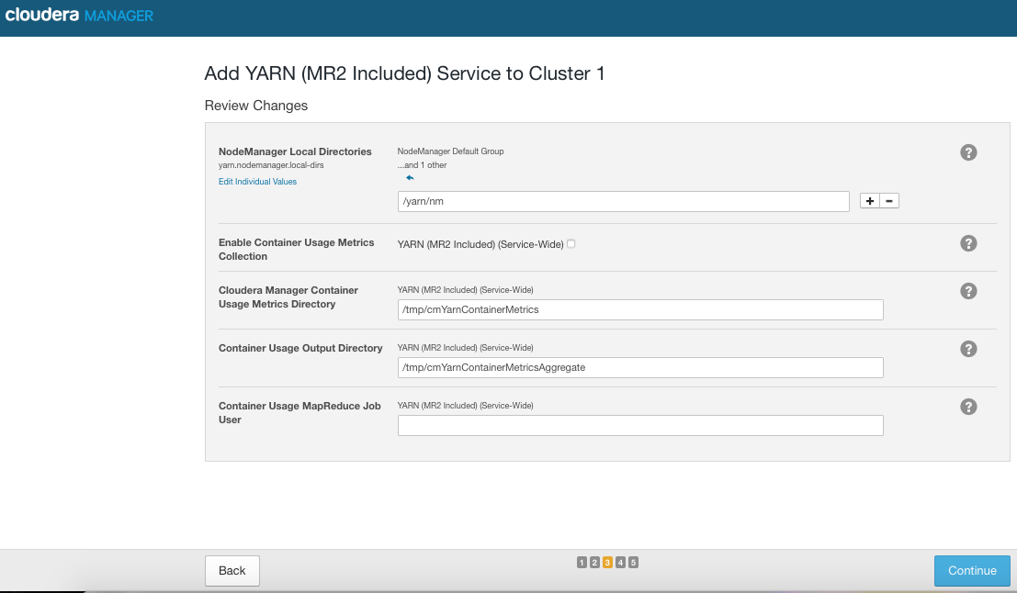

Click Continue

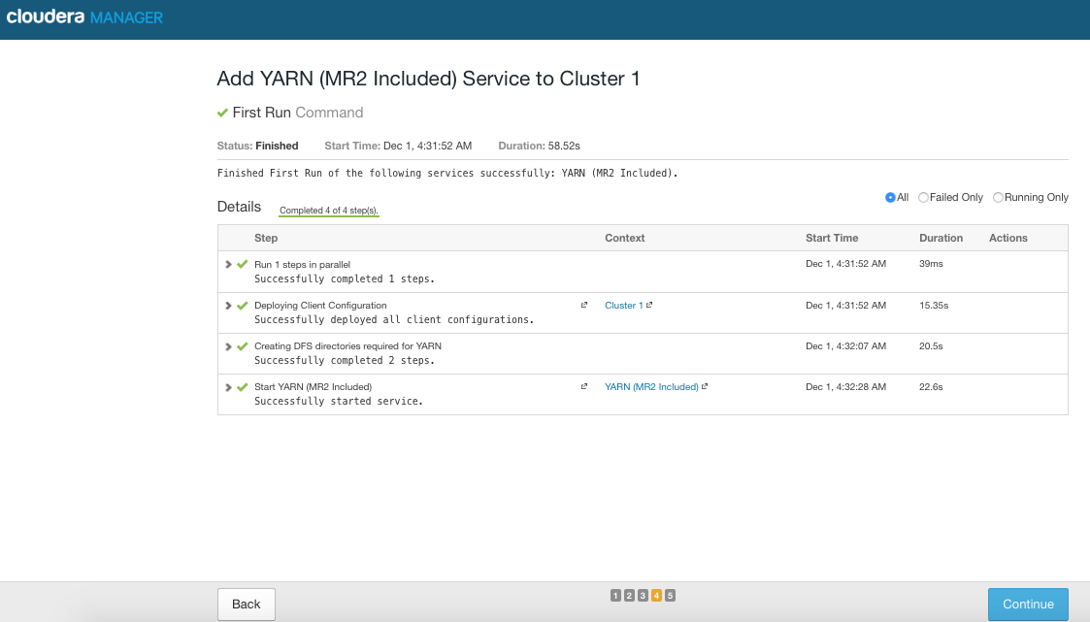

Click Finish

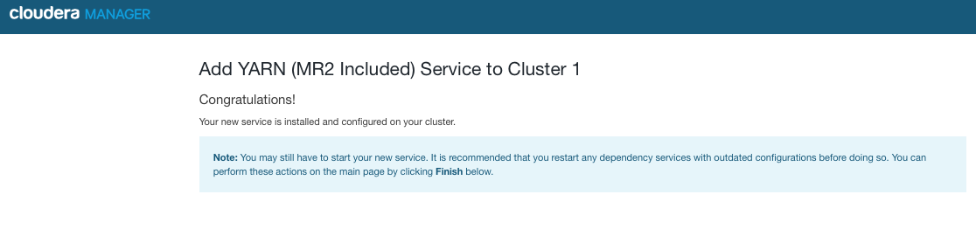

Restart Cluster

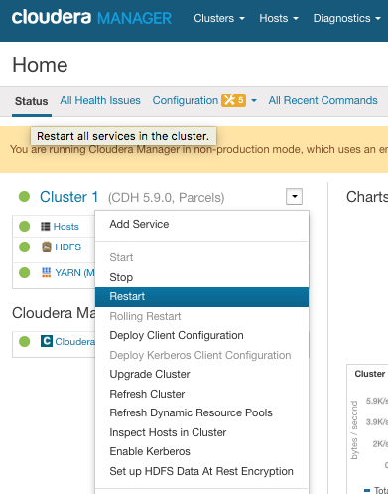

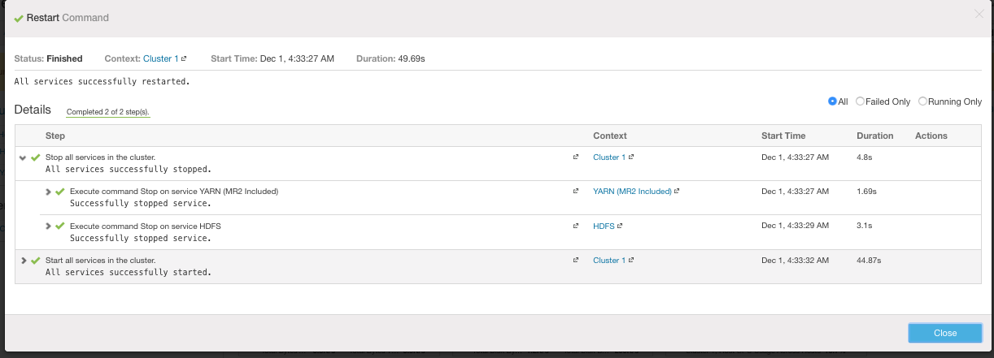

HDFS and Yarn services successfully started

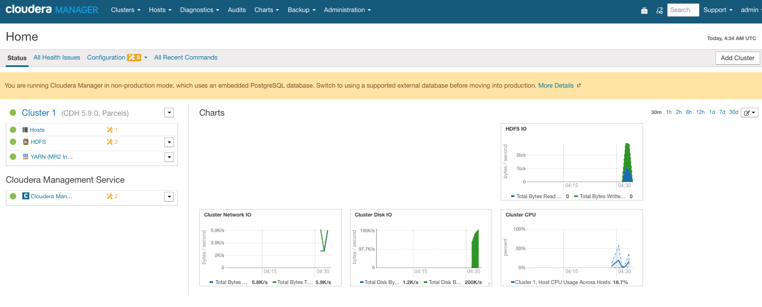

This completes, HDFS and Yarn installation procedure